Object Oriented Programming in Java

What is Object Oriented Programming (OOP)?
Object Oriented Programming is a programming paradigm based on the concept of objects, where data and behavior are bundled together.
Instead of focusing on functions, OOP focuses on:
- Real-world entities
- Objects
- Interactions between objects
Combine data + behavior into a single unit called an object.

Example
Think of a Car.
Car has:
- Properties → color, brand, speed
- Behavior → start(), accelerate(), brake()
In OOP, we model real-world objects into code.

What is a Class?
A Class is a blueprint or template used to create objects.
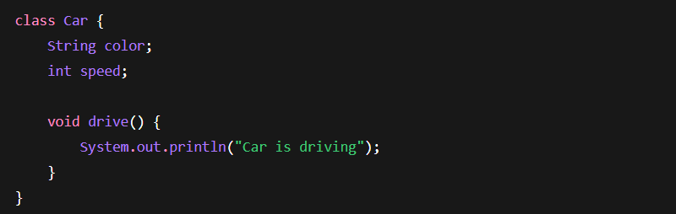
It defines:
- Properties (variables)
- Methods (functions)
What is an Object?
An object is an instance of a class, it represents a real-world entity.
Creating Object:
- Car → Class
- c1 → Object
- new → Memory allocation
Object Has:
- State → Properties
- Behavior → Methods
Data Members / Properties / Variables / Attributes
These are variables declared inside a class.
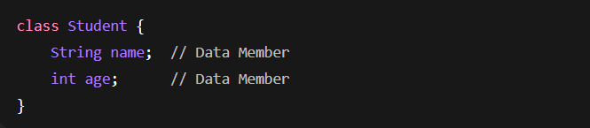They represent object state.
Methods / Functions / Member Functions
Methods define object behavior.
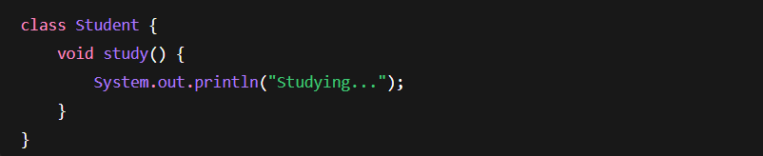
What is a Constructor?
A constructor is a special method used to initialize objects.
- Same name as class
- No return type
- Called automatically when object is created
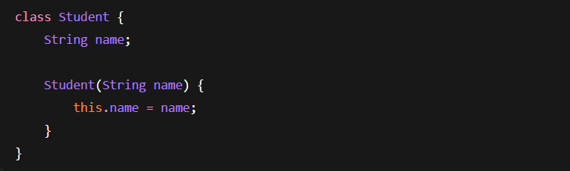
Types of Constructors
Default Constructor
Automatically provided by Java if no constructor is defined.
Java internally creates:

Parameterized Constructor
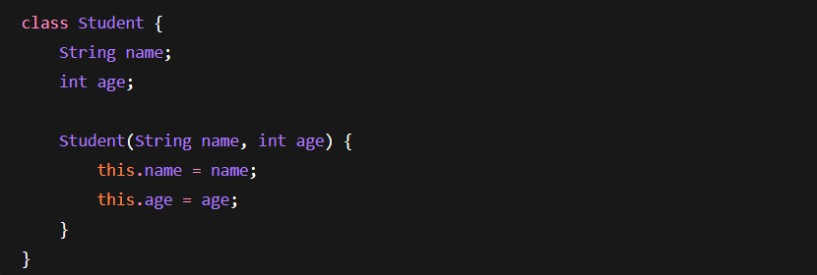
Copy Constructor (Manually Created)
Java doesn’t provide built-in copy constructor like C++.
We create manually:
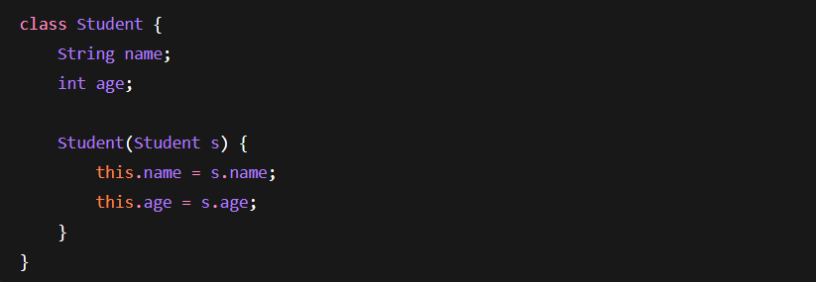
What About Destructors?
Java does NOT support destructors.
Why?
Because Java has:
Garbage Collection
Memory cleanup is automatic.
No need to manually free memory.
Pillars of OOP – Inheritance, Polymorphism, Encapsulation, Abstraction
Inheritance
Inheritance is a mechanism where one class acquires properties and methods of another class. extends keyword is used.
It promotes:
- Code reuse
- Logical hierarchy
- Extensibility
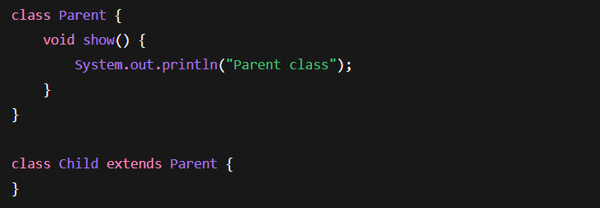
Types of Inheritance in Java
Single Inheritance
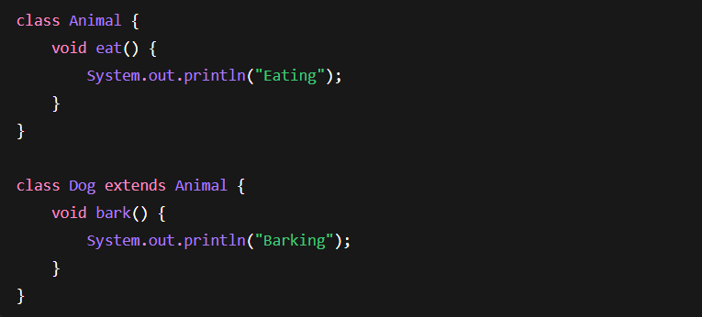
Multilevel Inheritance
Grandparent → Parent → Child
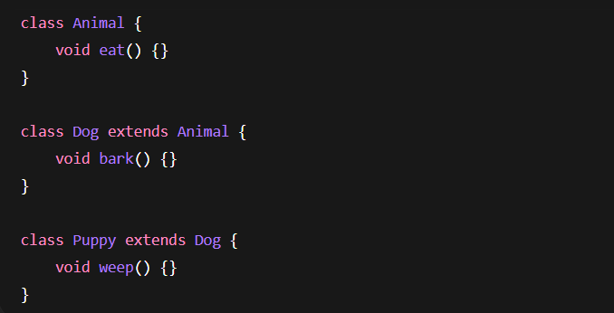
Hierarchical Inheritance
One parent → Multiple children
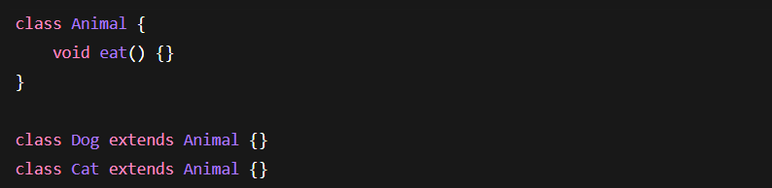
Multiple Inheritance (Important)
Java does NOT support multiple inheritance using classes.
❌ This is not allowed:
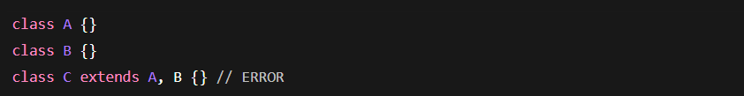

Diamond Problem
Imagine:


If B and C both override method of A,
and D extends both B and C,
Java wouldn’t know which method to call.
This creates ambiguity.

Solution: Interfaces
Java supports multiple inheritance via Interfaces.

What is an Interface?
An interface defines a contract.
It contains:
- Abstract methods
- By default public and abstract
- Cannot have instance variables
With interfaces Java allows:
- ✔ Multiple inheritance via interfaces
✔ No ambiguity
✔ No diamond problem

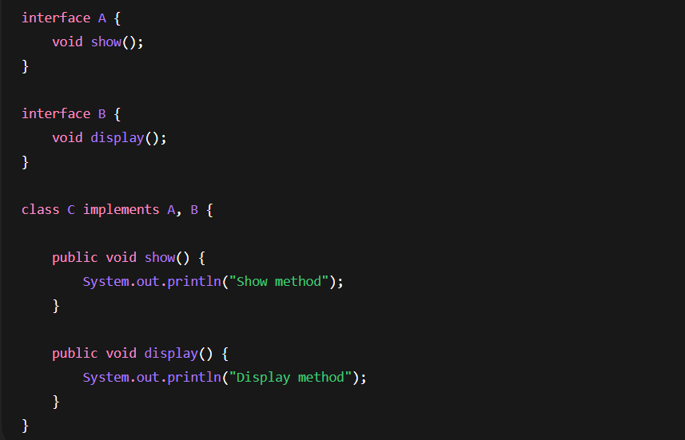

Extends vs Implements
Keyword | Used For
extends | Class inherits class
implements | Class implements interface

Polymorphism
Polymorphism means "many forms".
Same method name,
Different behavior.

Types of Polymorphism
- Compile-Time (Method Overloading)
- Run-Time (Method Overriding)
Compile-Time Polymorphism (Overloading)
Method name same, Parameters different.
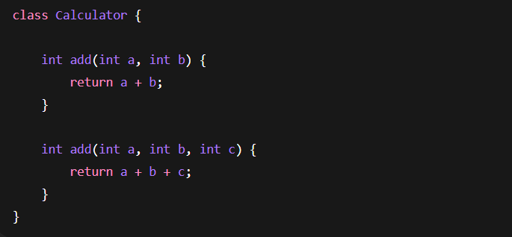Resolved at compile time.
Run-Time Polymorphism (Overriding)
Child overrides parent method.
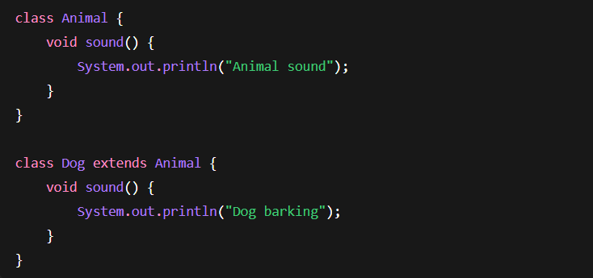
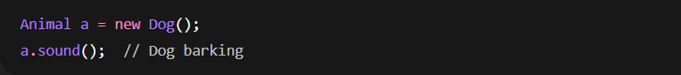
Method call decided at runtime.
This is called Dynamic Method Dispatch.
Encapsulation
Wrapping data and methods into a single unit and restricting direct access.
Achieved using:
- Private variables
- Public getter/setter methods
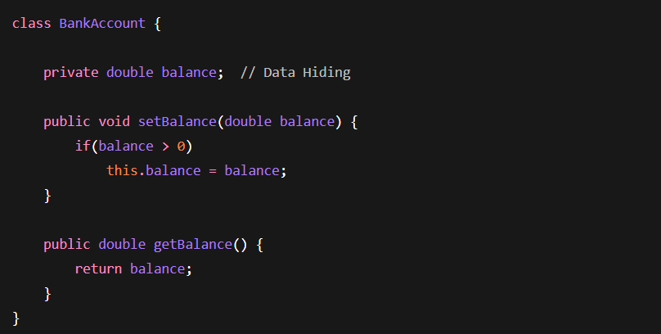
Here:
✔ Data is hidden
✔ Controlled access provided

Access Modifiers in Java
Modifier | Same Class | Same Package | Subclass | Other Package
private | Yes | No | No | No
default | Yes | Yes | No | No
protected | Yes | Yes | Yes | No
public | Yes | Yes | Yes | Yes

Data Hiding Implementation
Use private variables:
Provide controlled access:
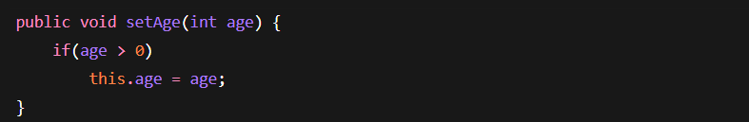

Abstraction
Hiding implementation details and showing only essential features.
Example:
You use ATM machine.
You don’t know internal logic.
You only know interface.
Achieved By:
- Abstract Class
- Interface
Abstract Class
Declared using abstract keyword.
Rules of Abstract Class
- Must be declared abstract
- Cannot be instantiated
- Can have abstract & non-abstract methods
- Can have constructor
- Can have static methods
- Can have final methods
Example:
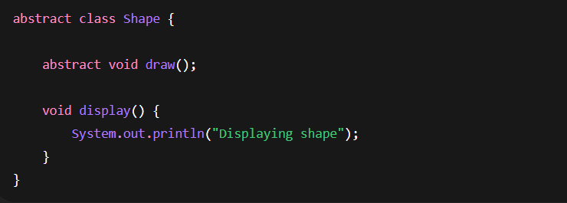
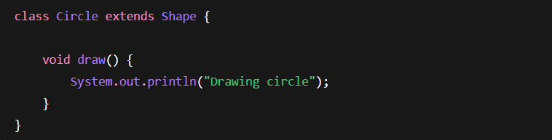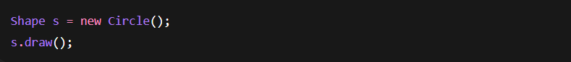
Abstract Class vs Interface
Feature | Abstract Class | Interface
Methods | Abstract + Concrete | Mostly abstract
Multiple Inheritance | No | Yes
Constructors | Yes | No
Access Modifiers | Any | Public only
Abstraction | Partial | Pure (before Java 8)

Pure vs Partial Abstraction
- Abstract Class → Partial Abstraction
- Interface → Pure Abstraction (conceptually)
🏦 Complete OOPS Example – Banking System
Step 1: Interface (Pure Abstraction)
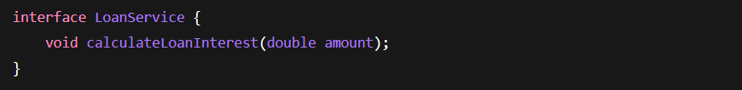
Step 2: Abstract Class (Partial Abstraction)
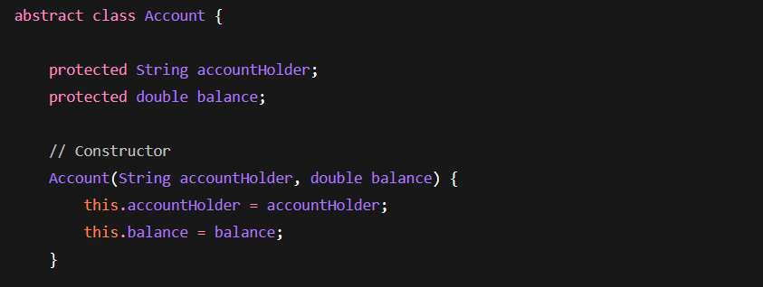
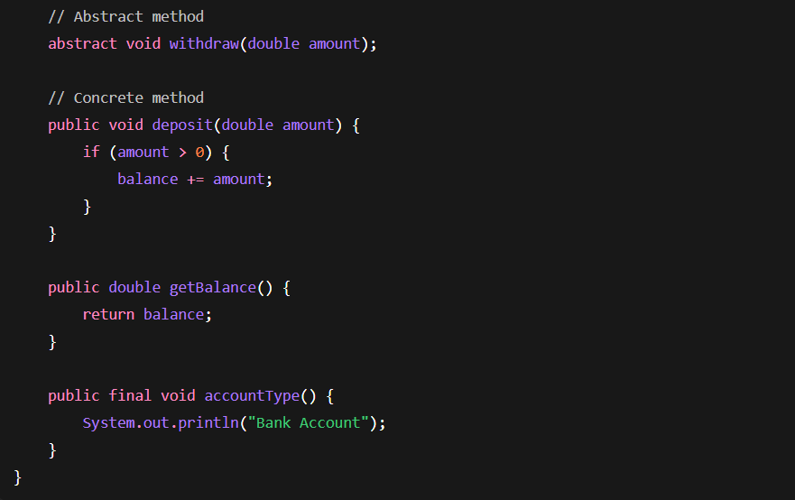
Step 3: Child Class (Inheritance + Polymorphism)
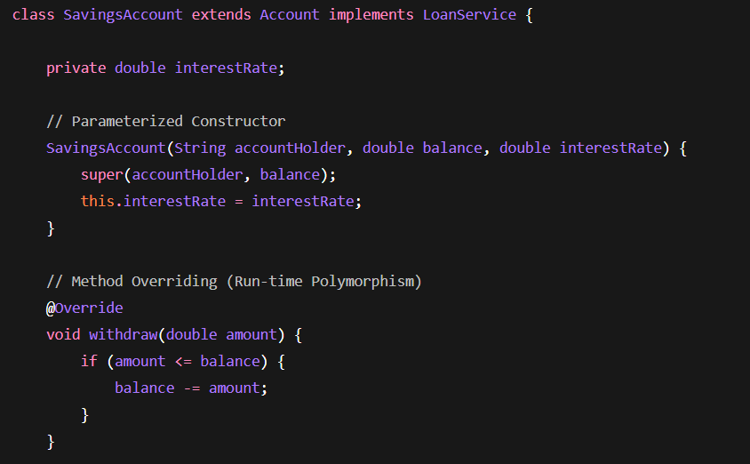
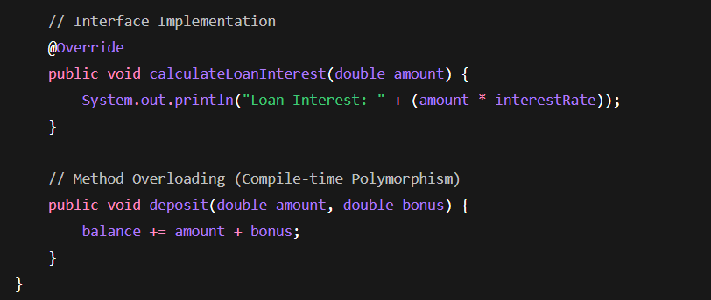

Step 4: Main Class (Object Creation + Polymorphism)
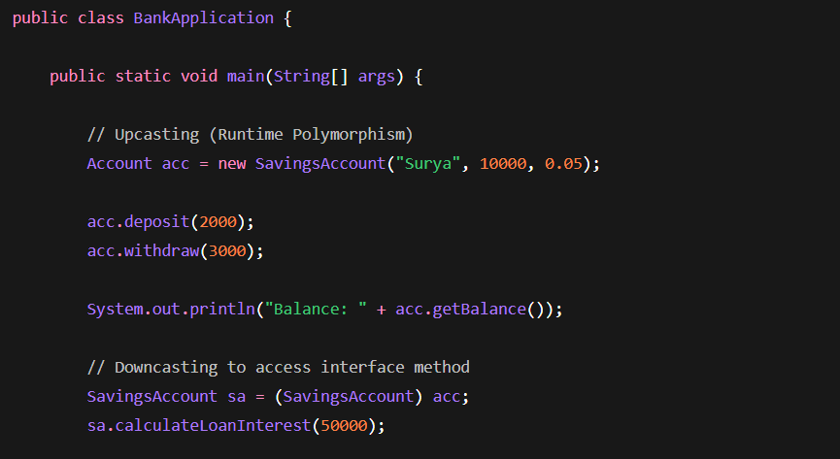
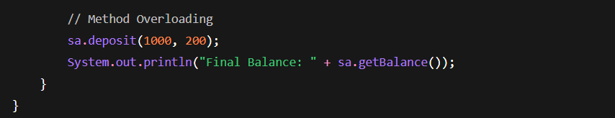
What Concepts Did We Just Use?
Concept | Where Used
Class | Account, SavingsAccount
Object | new SavingsAccount()
Constructor | Account(), SavingsAccount()
Encapsulation | private & protected variables
Inheritance | SavingsAccount extends Account
Interface | LoanService
Implements | SavingsAccount implements LoanService
Abstraction | abstract withdraw()
Method Overriding | withdraw()
Method Overloading | deposit()
Runtime Polymorphism | Account acc = new SavingsAccount()
Compile-time Polymorphism | deposit(int, int)
Final Method | accountType()

Important Interview Explanations

What is OOP?
OOP is a paradigm that models real-world entities into objects containing state and behavior.

Why OOP?
- Reusability
- Modularity
- Maintainability
- Security
- Scalability

What is the Diamond Problem?
Occurs in multiple inheritance when two parent classes override the same method and child inherits both.
Java avoids this by:
- Not allowing multiple inheritance with classes
- Supporting it via interfaces

Why Private Methods Are Not Polymorphic?
Because method overriding requires visibility.
Private methods are not inherited.

Why Use Abstract Classes?
When:
- You want common base behavior
- Some methods should be forced to implement
- You need constructors

Why Use Interfaces?
When:
- You want multiple inheritance
- You want complete abstraction
- You define a contract

Abstract Class vs Interface
Abstract Class | Interface
Partial abstraction | Pure abstraction
Has constructors | No constructors
Can have instance variables | Only constants
Single inheritance | Multiple inheritance

Compile-Time vs Run-Time Polymorphism
Compile-Time
- Method Overloading
- Decided at compile time
- Static binding
Run-Time
- Method Overriding
- Decided at runtime
- Dynamic binding

Complete OOPS Flow Summary
OOP in Java consists of:
- Class → Blueprint
- Object → Instance
- Constructors → Initialization
- Encapsulation → Data hiding
- Inheritance → Code reuse
- Polymorphism → Multiple behavior
- Abstraction → Hide implementation
- Interface → Contract

🚀 OOPS in Spring Boot – Backend Developer POV
POJO – Encapsulation in Action (POJO = Plain Old Java Object)
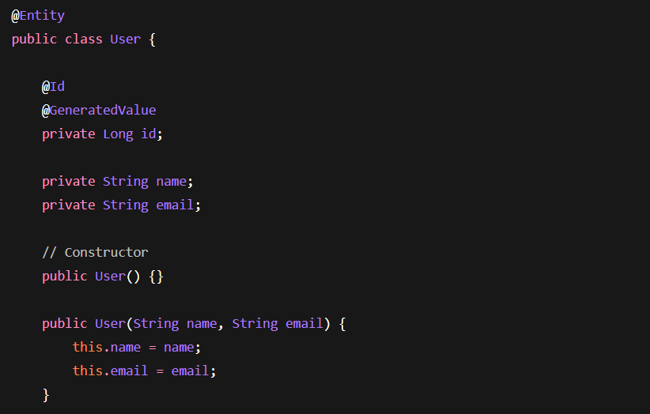
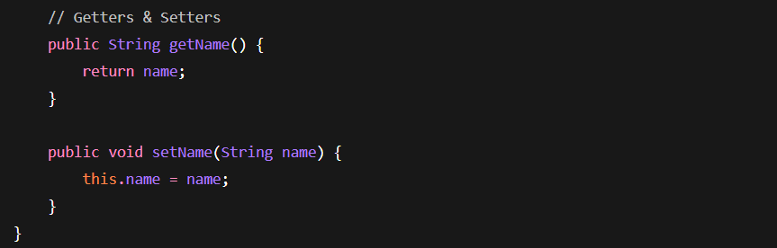
Repository Layer – Interfaces & Abstraction in Action
Spring Data JPA uses Interfaces heavily.
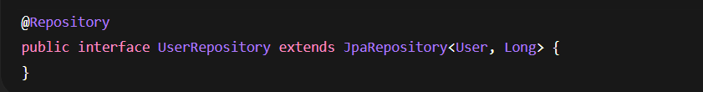
Service Layer – Business Logic + Dependency Injection
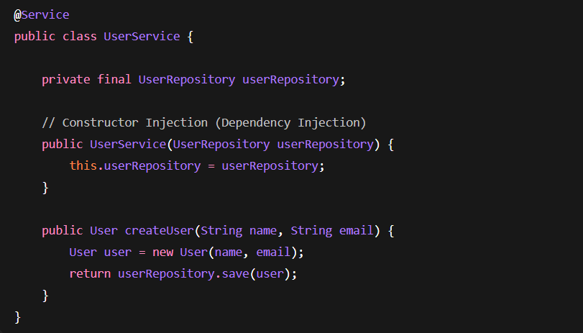
Controller Layer – MVC Pattern
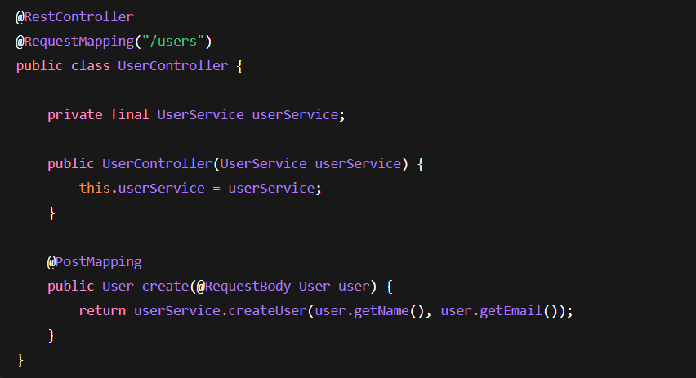

Dependency Injection – Polymorphism in Real Life
Dependency Injection is OOPS in action.
Instead of:
We do:
Spring injects correct implementation.
Why is this powerful?
Because you can switch implementation without changing service code.
Example:
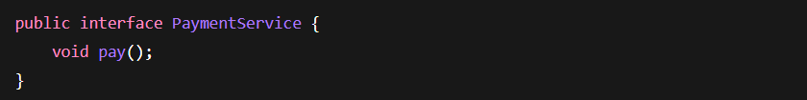Two implementations:
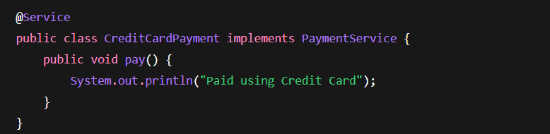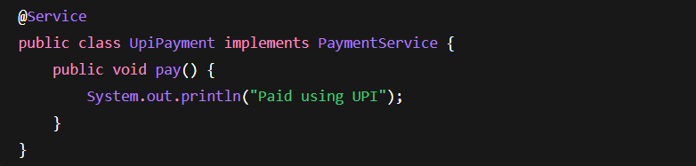Service depends on abstraction:
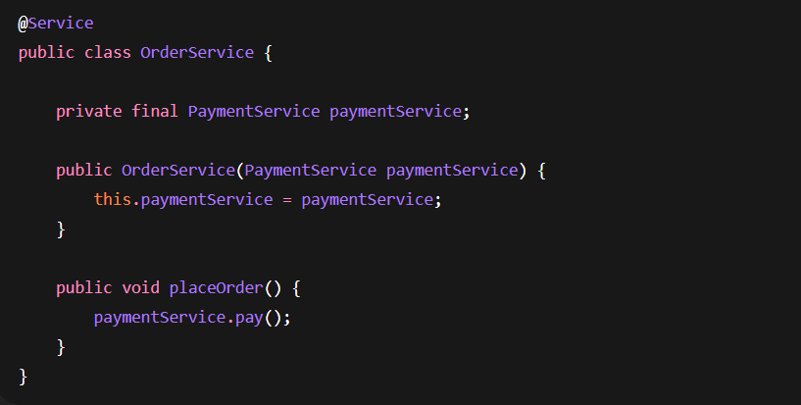
@Transactional – AOP + Abstraction
When you write:
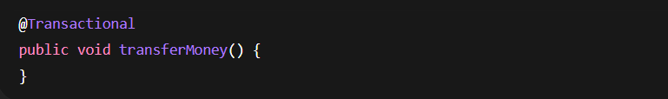Spring creates proxy.
You don’t see implementation.
Spring handles it.
Inheritance in Spring Boot
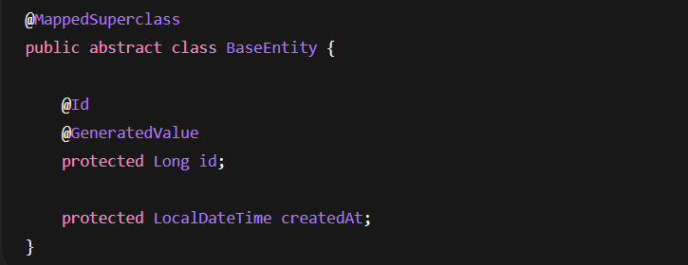
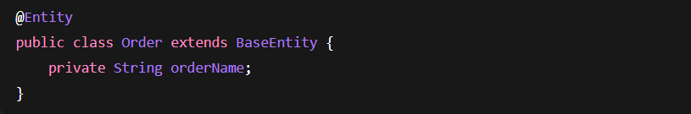
This is:
✔ Inheritance
✔ Code reuse
✔ Abstraction

DTO Pattern – Encapsulation + Abstraction
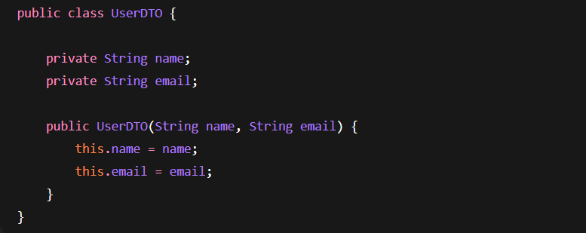You don’t expose entity directly.
You expose DTO.
This is:
✔ Encapsulation
✔ Abstraction
✔ Data hiding

🏗 End-to-End OOPS Mapping in Spring Boot
Spring Component | OOPS Concept
Entity | Class, Object, Encapsulation
Repository | Interface, Abstraction
Service | Abstraction, DI, Polymorphism
Controller | Encapsulation, Object Communication
@Transactional | AOP, Runtime Polymorphism
Bean | Singleton Pattern
DTO | Encapsulation
BaseEntity | Inheritance
Multiple Payment Services | Polymorphism

